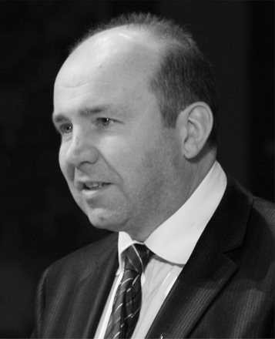

**Mass of Remembrance**

**Gerard Michael Joseph Patrick Mannion**

**25 September 1970 + 21 September 2019**

**4 October 2018**

**Dahlgren Chapel of the Sacred Heart**

**Georgetown University**

Rev. Leo D. Lefebure, Presider

*Matteo Ricci, S.J., Professor of Theology*

*Department of Theology and Religious Studies*

**Introductory Rite**

**Entrance Hymn** *(please stand)*The King of Love My Shepherd Is

*Hymnal (located beneath your seat), #712*

**Greeting**

*Priest: In the name of the Father, and of the Son, and of the Holy Spirit.*

**People: Amen**

*Priest: The grace of our Lord Jesus Christ and the love of God*

*and the fellowship of the Holy Spirit be with you all.*

**People: And with your spirit**

**Welcome** *(please be seated)* Christopher Celenza, Ph.D., D. Phil.

*Dean, Georgetown College*

**Opening Prayer** *(please stand)*

**Liturgy of the Word**

**Reading I** *(please be seated)*Job 19: 1, 23-27a

Amy Phillips, Lector

*Rare Materials Cataloger*

*Woodstock Theological Library*

*Lector: The Word of the Lord.*

**People: Thanks be to God.**

**Responsorial Psalm**

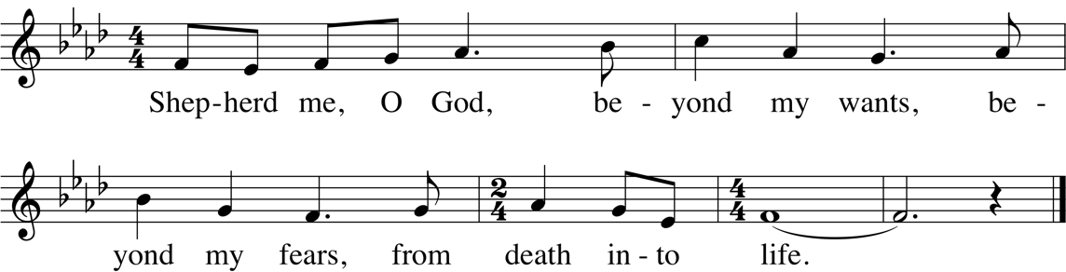



**Reading II** Revelation 21: 1-5a, 6b-7

Julia Lamm, Lector

*Professor*

*Department of Theology and Religious Studies*

*Lector: The Word of the Lord.*

**People: Thanks be to God.**

**Gospel Acclamation** *(please stand)*

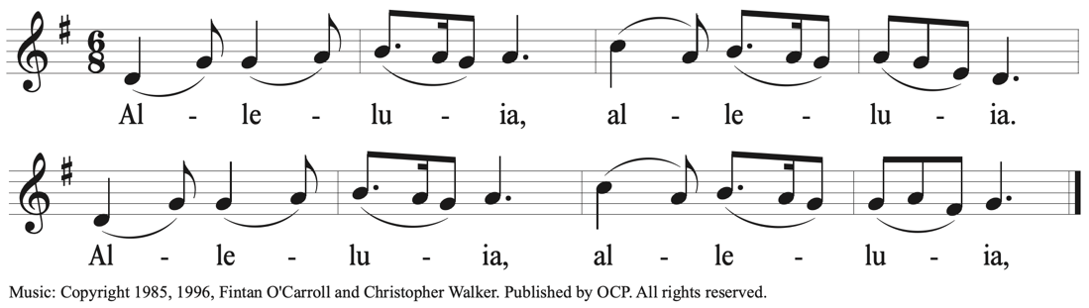

**Gospel** Luke 12: 35-38

*Priest: The Lord be with you.*

**People: And with your spirit.**

*Priest: A reading from the Holy Gospel according to Luke.*

**People: Glory to you, O lord.**

**~***Following the Gospel***~**

*Priest: The Gospel of the Lord*

**People: Praise to you, Lord Jesus Christ.**

**Homily** *(please be seated)* Rev. Dan Madigan, S.J.

*Director of Graduate Studies; Jeanette W. and Otto J. Ruesch Family Associate Professor*

*Department of Theology and Religious Studies*

**Prayers of the Faithful** *(please stand)* *Response:* Lord, hear our prayer

Brian Flanagan, Lector

*Associate Professor of Theology and Religious Studies*

*Marymount University*

**Liturgy of the Eucharist**

**Preparation of the Gifts and Altar** *(please be seated)*

Julie and Derek Wotherspoon, Maria Mannion, Grace Edgar, Teresa Kelly, gift bearers

*Family of Gerard Mannion*

Music during the Preparation of the Gifts and Altar The Coulin

Mitch Fanning, Fiddle

**Preface Dialogue** *(please stand)*

*Priest: Pray brethren, that my sacrifice and yours*

*may be acceptable to God, the almighty Father.*

**All: May the Lord accept the sacrifice at your hands,**

**for the praise and glory of his name,**

**for our good, and the good of all his holy Church.**

**~~~**

*Priest: The Lord be with you.* **All: And with your spirit.**

*Priest: Lift up your hearts.* **All: We lift them up to the Lord.**

*Priest: Let us give thanks to the Lord, our God.* **All: It is right and just.**

**Preface Acclamation** Mass of Creation

*(please kneel or be seated following the Preface Acclamation) Hymnal #198*

**Memorial Acclamation** Mass of Creation

*Hymnal #200*

**The Great Amen** *(please stand following the Great Amen)* Mass of Creation

*Hymnal #202*

**The Lord’s Prayer**

**Our Father, Who art in Heaven, hallowed be Thy name;**

**Thy Kingdom come, Thy**[**will**](http://www.catholic.org/encyclopedia/view.php?id=12332)**be done on earth as it is in Heaven.**

**Give us this day our daily bread;**

**and forgive us our trespasses as we forgive those who trespass against us;**

**and lead us not into temptation, but deliver us from evil.**

*Priest: Deliver us, Lord, we pray, from every evil, graciously grant peace in our days, that, by the help of your mercy, we may be always free from sin and safe from all distress, as we await the blessed hope and the coming of our Savior, Jesus Christ.*

**People: For the kingdom, the power and the glory are yours now and forever.**

*Priest: The Peace of the Lord be with you always.*

**People: And with your spirit.**

**The Breaking of the Bread** Mass of Creation

*(please kneel or be seated following the Lamb of God) Hymnal #204*

**Communion Rite**

*Priest: Behold the Lamb of God, behold him who takes away the sins of the world.*

*Blessed are those called to the supper of the Lamb.*

**People: Lord, I am not worthy that you should enter under my roof,**

**but only say the word and my soul shall be healed.**

*We welcome all to this celebration in peace and unity as brothers and sisters, all members of the human family. Because Catholics believe that the celebration of the Eucharist is a sign of the reality of the oneness of faith, life, and worship, members of those churches with whom we are not yet fully united are invited to come forward in procession and cross their arms as they approach the minister for a blessing.*

**Communion Procession** I am the Bread of Life

*(please be seated during the distribution of Communion) Hymnal #945*

**Song of Thanksgiving** May Holy Angels Lead You

*Hymnal #978*

**Prayer after Communion** *(please stand)*

**Concluding Rites**

**Words of Remembrance**

Richard Cushnie

*Deputy Director / First Secretary*

*Northern Ireland Bureau*

Peter Phan, Ph. D.

*Ellacuria Chair of Catholic Social Thought*

*Department of Theology and Religious Studies*

Grace Edgar

*Cousin of Gerard Mannion*

Amanda Elkin

*Partner of Gerard Mannion*

**Final Blessing and Dismissal**

**Concluding Hymn** Lord of All Hopefulness

*Hymnal #663*